Dear Parents and Carers 7th April 2022

Year 2 Trip to RHS Wisley Gardens – Tuesday 21st June 2022 Cost £10.14
Depart from school 9.00 am Return approx 3.00pm

We have arranged for Year 2 to visit RHS Garden Wisley as part of our ‘Wonderful World’ topic. This trip will be led by Mrs Anna Fennell and the children will be learning about a variety of plants and wildlife. We believe that by taking the children on education visits we enhance and broaden the curriculum we are able to offer. Off-site activities also help to develop a child’s personal and social skills.
As you know this visit requires the generosity of your contributions without which it would not take place. The cost has been carefully calculated to cover the coach hire and entrance fee. All monies must be received by 6th June 2022.
If anyone has difficulty meeting the full costs, please make an appointment to see me. If there are not sufficient contributions the school has no way of making up the shortfall. In this eventuality we will have to cancel this valuable day out. Payments can be made by either cash or cheque in a named envelope or via Tucasi.
ON THE DAY YOUR CHILD WILL NEED:
- A packed lunch (no chocolate or sweets please) with a water bottle (no fizzy drinks or cartons )in a rucksack (please note they will carry this bag with them all day)
- School uniform and sensible shoes must be worn
- Clothing appropriate for the weather e.g waterproof coat, sun hat, sun cream.

The Teachers will open Year 2 classroom doors at 8.30am, please arrive promptly.
If your child needs travel sickness tablets please give them before he/she comes to school.
Please find attached an Educational Visit Information and Consent Form. Please ensure you complete both sides of this form and return to the School Office with your payment.
Some classes may be looking for volunteers to help on this trip. Please do let your child’s Teacher know if you are able to help especially if you already have a DBS. In the event of lots of volunteers coming forward, we will pull names out of a hat. Please be aware that we complete DBS checks on all our volunteers and DBS application forms are available from the school office.

We have carried out a full risk assessment which includes safety measures in relation to Covid and as part of this, all volunteers will be required to take a Lateral Flow Test the day before and wear a mask whilst travelling on the coach. The coach company and RHS Wisley Gardens all have Covid safety measures in place.

Yours sincerely,
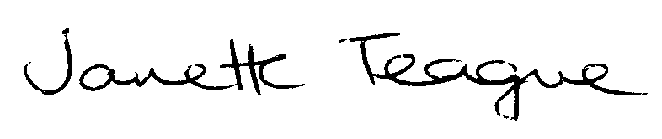

Janette Teague
Headteacher

