7th April 2022

Dear Parents and Carers,

**Year R Trip to Bekonscot Model Village – Tuesday 17th May 2022 Cost: £18.06**

**Depart from School 9.00am Return Approximately 3.00pm**

We have arranged for Year R to visit Bekonscot Model Village as part of our topic on transport. The trip will be led by Mrs Lynda Hallett and during the visit the children will learn about different styles of transport.

We believe that by taking the children on education visits, we enhance and broaden the curriculum we are able to offer. Off-site activities also help to develop a child’s personal and social skills.

As you know, this visit requires the generosity of your contributions without which it will not take place. The cost has been carefully calculated to cover the coach hire, entrance fee and train ride. All monies will be required by **6th May 2022**.

If anyone has any difficulty meeting the full costs, please make an appointment to see me. If there are not sufficient contributions the school has no way of making up the shortfall. In this eventuality we will have to cancel this valuable day out. Payments can be made either by cash or cheque in a named envelope or via Tucasi.

ON THE DAY YOUR CHILD WILL NEED:

1. A packed lunch *(no chocolate or sweets please)* with a water bottle (no fizzy drinks or cartons please) in a small named lunch bag. No rucksacks.
2. School uniform and sensible shoes must be worn.
3. Clothing appropriate for the weather eg. waterproof coat, sun hat, sun cream.

**The Teachers will open Year R classroom doors at 8.40am, please arrive promptly.**

**If your child needs travel sickness tablets please give them before he/she comes to school.**

Please find attached an Educational Visit Information and Consent Form. Please ensure you complete both sides of this form and return to the School Office with your payment.

Some classes may be looking for volunteers to help on this trip. Please do let your child’s Teacher know if you are able to help especially if you already have a DBS. In the event of lots of volunteers coming forward, we will pull names out of a hat. Please be aware that we complete DBS checks on all our volunteers and DBS application forms are available from the school office.

We have carried out a full risk assessment which includes safety measures in relation to Covid and as part of this, all volunteers will be required to take a Lateral Flow Test the day before and wear a mask whilst travelling on the coach. The coach company and Bekonscot Model Village all have Covid safety measures in place.

Yours sincerely,

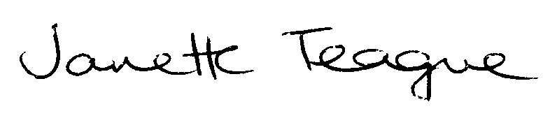

Janette Teague

Headteacher